TUTORIAL 3 – SCREENSHOT REPORT
PRODUCT & CART MODULE
Website: DemoBlaze
TC01 – View Products
Test Case | Check that products are displayed correctly on the website.
Execution | Open website → Check the Products section
Test Data | DemoBlaze home page
Expected Result | Products should be visible with product names/images.
Actual Result | Products are displayed on the home page.
Status | PASS
Screenshot:
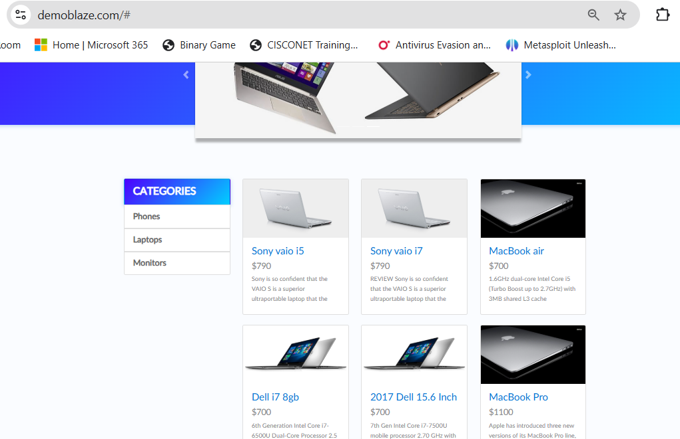

TC02 – Select Product
Test Case | Check that a user can select a product from the product list.
Execution | Open website → Click a product
Test Data | Any available product
Expected Result | Selected product should open.
Actual Result | The selected product opens successfully.
Status | PASS
Screenshot:
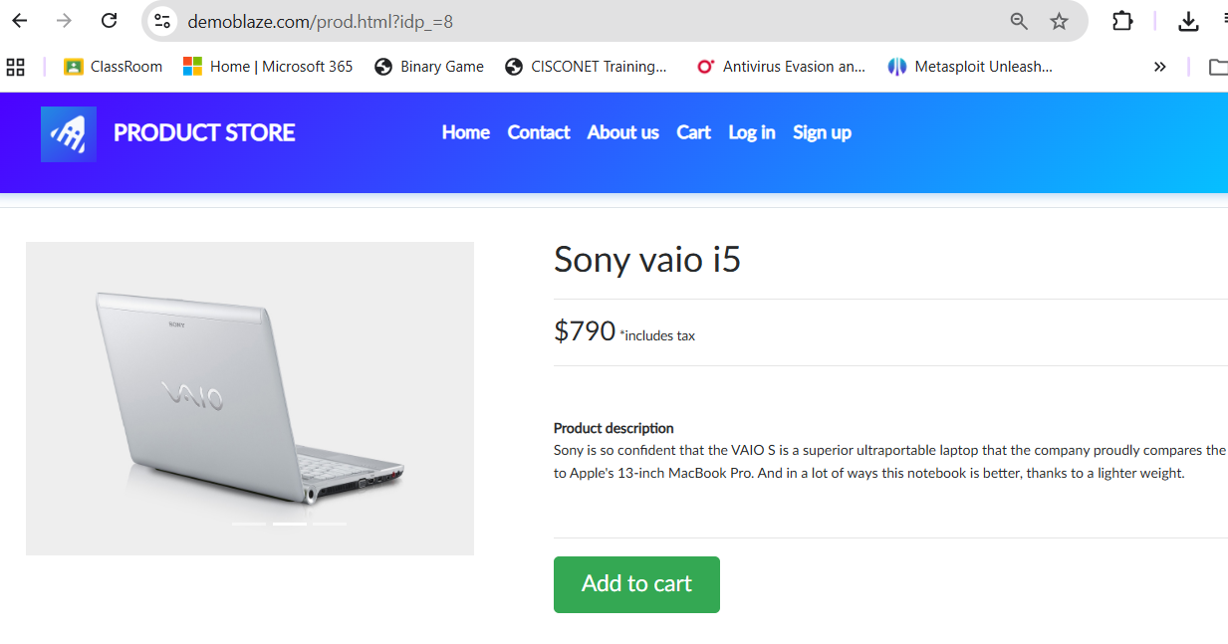

TC03 – View Product Details
Test Case | Check that product details are shown correctly.
Execution | Open a product
Test Data | Selected product
Expected Result | Product name, price and details should be displayed.
Actual Result | Product details are displayed for the selected product.
Status | PASS
Screenshot:
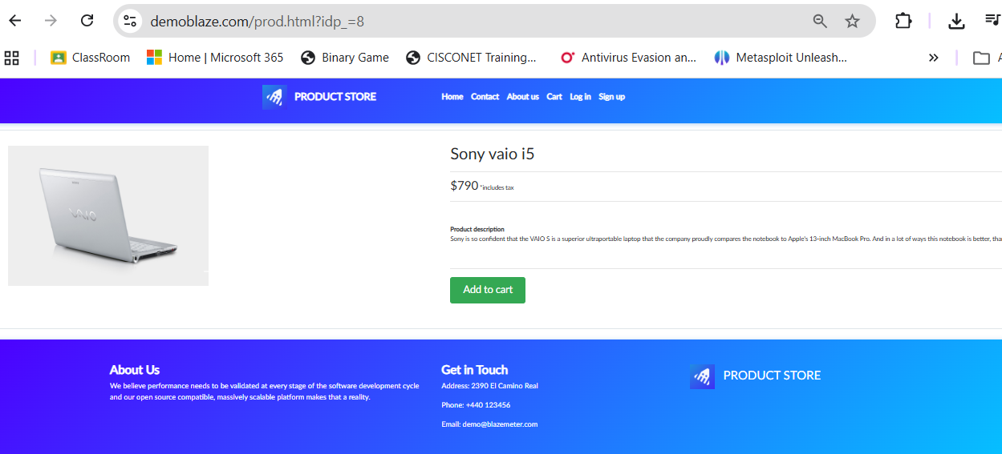

TC04 – Add Product
Test Case | Check that a product can be added to the cart.
Execution | Open product
Test Data | Any available product
Expected Result | Product should be added to the cart.
Actual Result | Product is added to the cart successfully.
Status | PASS
Screenshot:
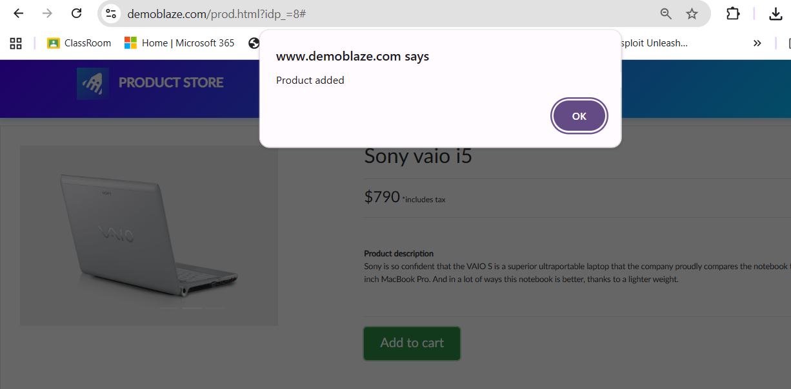

TC05 – Open Cart
Test Case | Check that the cart page opens correctly.
Execution | Click Cart
Test Data | Cart
Expected Result | Cart page should open and show the cart contents.
Actual Result | Cart page opens successfully.
Status | PASS
Screenshot:
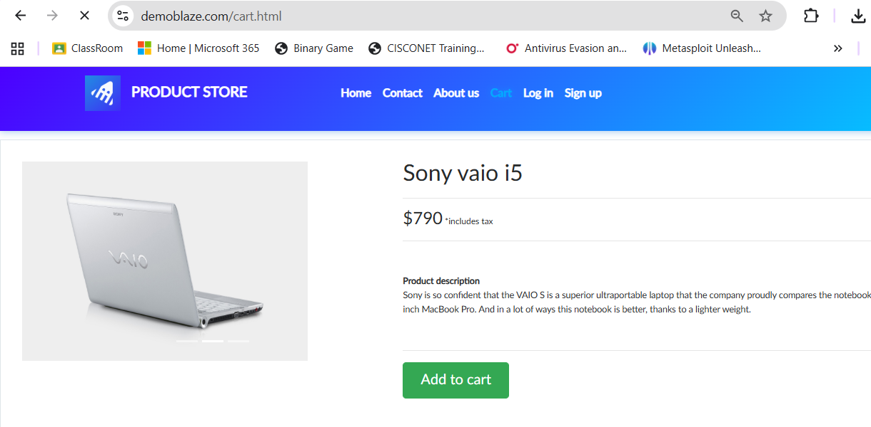

TC06 – Verify Product in Cart
Test Case | Check that the added product appears in the cart.
Execution | Open Cart
Test Data | Added product
Expected Result | The selected product should be visible in the cart.
Actual Result | Added product is visible in the cart.
Status | PASS
Screenshot:
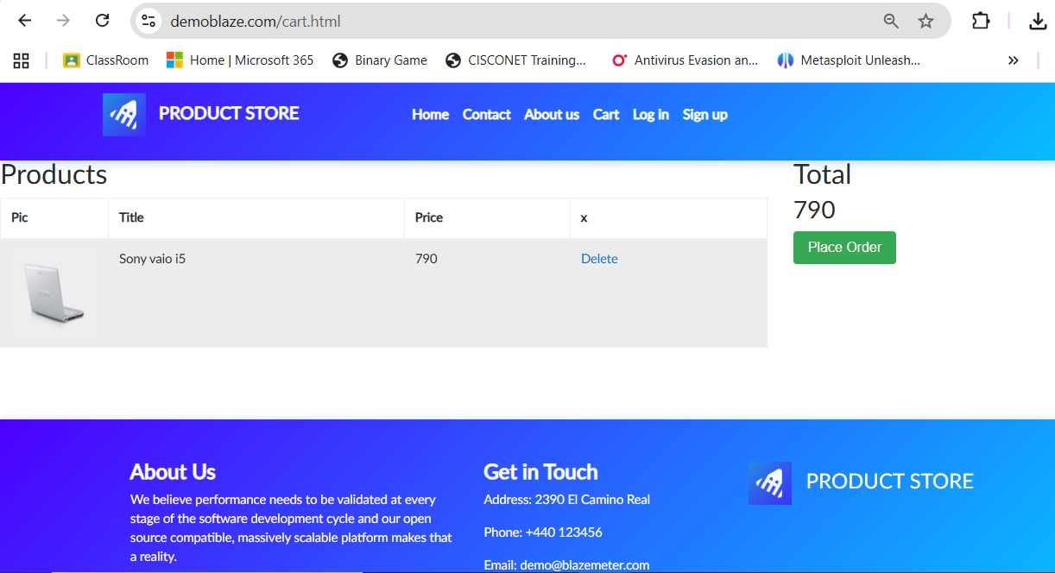

TC07 – Remove Product
Test Case | Check that a product can be removed from the cart.
Execution | Open Cart
Test Data | Product in cart
Expected Result | The product should be removed from the cart.
Actual Result | The product is removed from the cart.
Status | PASS
Screenshot:
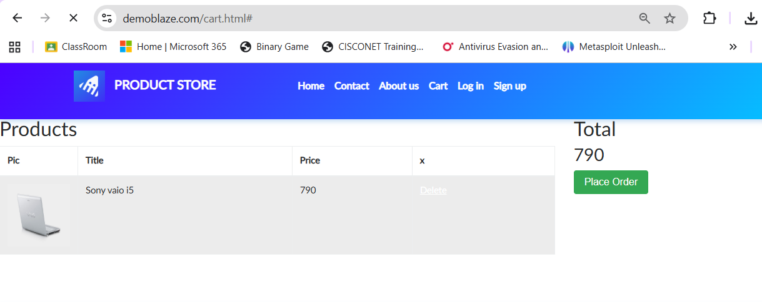

Requirement Review
Requirement | Test Case | Clear / Unclear | Reason | Status
User should be able to view available products. | TC01 | Clear | The requirement is directly visible and testable. | PASS
User should be able to select a product. | TC02 | Clear | A product can be selected and opened. | PASS
User should be able to view product details. | TC03 | Clear | Product details can be checked from the product page. | PASS
User should be able to add a product to the cart. | TC04 | Clear | The Add to cart action is directly testable. | PASS
User should be able to open the cart. | TC05 | Clear | Cart navigation can be checked easily. | PASS
Added product should be visible in the cart. | TC06 | Clear | The product presence can be verified in the cart. | PASS
User should be able to remove a product from the cart. | TC07 | Clear | The Delete action and cart state are testable. | PASS
Test Execution Summary
Total Test Cases | 7
Passed | 7
Failed | 0
Blocked | 0
Pass % | 100%
Overall Result | PASS

